CROSS-BORDER TIPS FOR MANUFACTURING SECTOR EMPLOYEES DURING COVID-19

Table of Contents

SECTION 1: INTRODUCTION 3
SECTION 2: CROSSING THE BORDER - DOCUMENTATION 4
2.1 Documentation to Bring 4
2.2 Additional Information: 4
SECTION 3: CROSSING THE BORDER - TIPS FOR SAFE BUSINESS TRAVEL 6
3.1: Tips for the Business traveller while away from home (Day Trip) 6
3.2 Tips for the Business traveller while away from home (Overnight or Multi-Day Trips) 7
3.3: Considerations for safe interactions with Border Services Officers: 7
3.4: What Border Operators (Bridge and Tunnel Operators) Are Doing to Mitigate Covid-19 Concerns: 7
SECTION 4: WHAT TO EXPECT AT THE BORDER CROSSING 8
4.1 A Canadian Business Traveller returning home to Canada 8
4.2 A Canadian Business Traveller visiting a customer/client in the USA 9
4.3: A US Business Traveller Returning Home to the USA 9
4.4: A US Business Traveller visiting a customer/client in Canada 10
SECTION 5: RESOURCES TO SELF-MONITOR AND SELF-ISOLATE 11
5.1 Resources needed to self-monitor or quarantine (self-isolate): 11
5.2 The following steps should be taken if the employee is required to self-monitor: 11
5.3 The following steps should be taken if the employee is required to quarantine (self-isolate): 12
5.4 What to do if COVID-19 symptoms develop: 12
ANNEX A: Essential Worker Template Letters I
ANNEX A.1(i): Letter of Introduction: Canadian Employee Traveling to the USA I
ANNEX A.1(ii): Letter of Invitation: Canadian Employee Traveling to the USA III
ANNEX A.1(iii): Owner-Operator Letter of Essential Travel: Canadian Business Traveler V
ANNEX A.2(i) Letter of Introduction: U.S. Business Traveller to Canada VII
ANNEX A.2(ii) Letter of Invitation: U.S. Business Traveller to Canada IX
ANNEX A.2(iii) Owner-Operator Letter of Essential Travel: American Business Traveler XI
APPENDIX 1.1: BORDER RELATED RESOURCES XIII
APPENDIX 1.2: HOW TO SELF-MONITOR XIV
APPENDIX 1.3: SELF-MONITORING VS. SELF-ISOLATION XV
APPENDIX 1.4: CBP REGULATIONS XVI
APPENDIX 1.5: QUARANTINE ACT XVIII
Crossing the Border: Quick Tips for Business Travelers 33

SECTION 1: INTRODUCTION

Not unlike the rest of the economy, the manufacturing sector has been hit hard by the COVID-19 pandemic. While the manufacturing sector has been deemed an essential workplace since the outbreak, the sector continues to face a number of challenges with the economy opening up. A key area concern is crossing the border. On March 21, 2020, the Governments of Canada and the USA instituted a temporary 30-day restriction on all non-essential travel at the Canada-U.S. border. The ban on non-essential travel has since been extended to July 31, 2020 and will likely be extended beyond that date. Thus, it is important that border authorities and industrial organizations within Canada and the USA work together to continue to facilitate bi-national trade, including the movement of business travellers that help support our integrated supply chain.

Many manufacturing companies in Canada are closely integrated into a supply chain that transcends the Canadian-US border. Passenger and Commercial vehicles want their border crossing to go smoothly and with fewer delays. The best way to ensure this happens is to know what to expect and be prepared. Whether you are returning home to Canada or entering the USA, this document will provide helpful tips and tools to navigate your trip across the border. This document is intended to serve as an evergreen document to inform the customs security process during COVID-19.

SECTION 2: CROSSING THE BORDER - DOCUMENTATION

2.1 Documentation to Bring
- Passport
- Essential Worker Letter (Please see ANNEX A for a template letter. Please select the letter that best corresponds to your situation. Once completed, the letter signals to the Border Services Officers the business traveller’s ability to move freely through the border and should be presented when requested.)
- For travel to/returning to the United States, it is recommended that business travellers keep a copy of U.S. Customs and Border Protection (CBP) statement on essential travel on hand should it be required for clarification purposes: (APPENDIX 1.4) https://www.federalregister.gov/documents/2020/06/24/2020-13676/notification-of-temporary-travel-restrictions-applicable-to-land-ports-of-entry-and-ferries-service (Another Useful document “ What is Essential Travel: https://help.cbp.gov/s/article/Article-1660?language=en_US)
- For travel to/returning to Canada, it is recommended that business travellers keep a copy of the Canadian Government’s List of Acts and Regulations on hand should it be required for clarification purposes. The exact paragraph needed will be found under “Group Exemption” but it is recommended that the entire document be on hand. (APPENDIX 1.5) https://www.canada.ca/en/public-health/corporate/mandate/about-agency/acts-regulations/list-acts-regulations.html

2.2 Additional Information:
- All individuals crossing the border should consider keeping up to date with COVID-19 related issues, including jurisdictional curfews and/or lockdowns.
- If possible, employees should have available a copy of building COVID-19 protocols issued by the home company and the customer’s company. These documents may be requested by the Border Services Officers (CBP and CBSA).
- When speaking to a Border Services officer (CBP and CBSA), it will be important to communicate that the purpose of your travel is essential. This is where the Essential Worker Letter will help to communicate the purpose of your trip and the essential nature of the trip. In brief, both Canada and the USA have deemed trade and the movement of people within the manufacturing sector to be essential travel.
- As of mid-April, CBSA officers began enforcing the order by Public Health Agency of Canada requiring that persons that are exempt from mandatory quarantine are still required to wear an appropriate mask or face covering upon entry into Canada, and that all travellers arriving in Canada will be required to wear a non-medical mask or face covering to proceed to their final destination within Canada to mitigate the potential spread of COVID-19.
- While it is not yet necessary, should you have been recently tested for COVID-19, you may want to have your results on hand.
- Be courteous and respectful at all times.

NOTE: It may be beneficial to Call CBSA / CBP before attempting to cross the border. However, the final decision for entry / refusal rests with the border official at the port of entry and officers cannot guarantee passage over the phone. You can contact CBSA / CBP at:
• CBP: Locate phone numbers for the relevant US ports of entry that will be used here: https://www.cbp.gov/contact
• CBSA: Within Canada 1-800-461-9999 (hotline)

NOTE: The Public Health Agency of Canada (PHAC) gained increased powers to ask for personal information, at the Canada-U.S. border through an Order in Council (OIC) on June 29. CBSA has stated that PHAC officials, like CBSA officers, are not restricted to any specific questioning and that questions from public health officials at the border are solely intended to identify the potential public health risk and how it could be best managed. As with any border crossing, drivers can still expect to be questioned about their recent travel, whether they are symptomatic, or have recently come into contact with someone who has contracted the virus. Essential workers crossing the border could be asked to provide personal information, such as their contact info, to public health officials. Additional questioning can be expected when entering Canada from the United States until August 31, which is the date the OIC is repealed.

SECTION 3: CROSSING THE BORDER - TIPS FOR SAFE BUSINESS TRAVEL

3.1: Tips for the Business traveller while away from home (Day Trip)
Do NOT make ANY unessential stops while in the United States. Any travel that can be deemed non-essential is subject to 14-day quarantine. Thus, all employees should:
- Travel in a safe reliable car
- Ensure one has enough gas to transport to and from work
- Bring a lunch unless there is food available at the worksite
- Do NOT stop anywhere besides the worksite
- Try to limit the number of people crossing the border
- There should be NO more than 1 person occupying the car
- Wear a mask while visiting customer
- Attempt to limit the frequency of face-to-face contact (minimum of 2m distance)
- If possible, keep all document sharing electronic
- Attempt to limit casual (social) interactions that normally occur at work
- Do not report to work if yourself or a member of your household is sick
- Try and take breaks away from large groups
- Practice cough/sneezing etiquette (covering mouth, away from co-workers, using one’s sleeve, etc.)
- Carry hand sanitizer and frequently wash hands
- Wash or sanitize hands after making or receiving deliveries.
- Bring sanitized wipes (if they are not provided) and clean all workstations
- Do NOT touch your face
- Where possible, wear gloves when interacting with high contact areas. Do not touch your face with gloved hands. Take care when removing gloves. Ensure you wash your hands after removing them
- Wash your clothes as soon as you get home
- If possible, work behind barriers (plexiglass, etc.)
- Be mindful of high touch areas and conduct regular cleaning in the plant and in the offices
  - If cleaning cannot be done ensure hands are disinfected after contact.
High contact areas include but are not limited to:
- Door handles
- Lights
- Bathrooms
- Community Office Supplies (Copiers, Pens, Etc.)
- Service counters
- Card payment machines
- Break rooms

3.2 Tips for the Business traveller while away from home (Overnight or Multi-Day Trips)
Business travellers that are taking overnight or multiday trips should follow the tips referenced in section 3.1 with the exception of not stopping anywhere but the workplace. The business traveller should still ensure that no unnecessary risks are taken. If the border officer believes that non-essential activities occurred during the trip the employee can be subject to quarantine.

Additional Tips for Overnight / Multi-day Business Travelers:
- Keep track of your daily schedule and stops. This will help ensure the Border Officer knows that no unnecessary risks were taken
- If possible, have food / supplies delivered to your place of residence
- Try to limit human contact both at and outside of work

3.3: Considerations for safe interactions with Border Services Officers:
  - Avoid handling cash and paperwork, directly, use medical gloves, if possible and wash hands immediately after completing your task
  - Business travellers should avoid placing their Identification in their mouth while pulling up the primary inspection lane to hand to a Border Services Officer
  - When travelling, ensure wipes and sanitizers are available on-hand.
  - As per Public Health Agency of Canada requirements, persons that are exempt from mandatory quarantine are still required to wear an appropriate mask or face covering upon entry into Canada, and that all travellers arriving in Canada are required to wear a non-medical mask or face covering

3.4: What Border Operators (Bridge and Tunnel Operators) Are Doing to Mitigate Covid-19 Concerns:
  - Modifying shift schedules for operations staff (toll attendants and janitorial) to minimize overlaps and internal contact between staff
  - Removing lane / booth rotations within single shifts for toll attendants
  - Increased sanitization of all operational areas for staff, including modifying procurement practices to use stronger cleansing products
  - Implementing cashless transactions for passenger vehicles to reduce probability of contamination for drivers and officers
  - Duty-Free stores remaining open (Ambassador Bridge) 24/7 to provide gas, restrooms, and the ability to purchase products and parking for rest periods
  - U.S. bound duty-free store at the Blue Water Bridge remains open which has washroom facilities, coffee shop, fax services and currency exchange

SECTION 4: WHAT TO EXPECT AT THE BORDER CROSSING

NOTE: In Canada the term quarantine is used. It is synonymous with self-isolate which is the term used in America.

NOTE: depending on the crossing type you may need to pay a toll before or after crossing through the security screening. Consider using a CC at one of the cashless options where limited human contact is offered.

The following section provides a summary of four possible scenarios and what a business traveler is likely to face when crossing.

4.1: A Canadian Business Traveller returning home to Canada
4.2: A Canadian Business Traveller visiting a customer/client in the USA
4.3: A US Business Traveller returning to the USA
4.4: A US Business Traveller visiting a customer/client in Canada

4.1 A Canadian Business Traveller returning home to Canada

 | Do NOT make any stops between your place of work and the Border
Have documents ready (See section 2) and approach CBSA Officer
See ANNEX A.1(i) and ANNEX A.1(ii)
 | The CBSA Officer will decide if you have to:
Self-Monitor (This is most likely) |  | Quarantine
See section 5.1, 5.2, & 5.3 |  | See section 5.1, 5.2, & 5.4
 |  | You MUST comply with the Officer's decision

4.2 A Canadian Business Traveller visiting a customer/client in the USA
Have documents ready (See section 2) and approach CBP Officer
See ANNEX A.1(i) and ANNEX A.1(ii)
If you are let through: |  |  |  | If you are not let through:
Proceed to place of work (Do NOT make any stops between the Border and your place of work) |  |  |  | Proceed back to Canada and inform the CBSA Officer that you did not enter the USA
Follow the tips given in section 3.1

For Canadian residents ONLY CBSA Officers can mandate quarantine NOT CBP Officers

4.3: A US Business Traveller Returning Home to the USA
 | Do NOT make any stops between your place of work and the Border
Have documents ready (See section 2) and approach CBP Officer
See ANNEX A.2(i) and ANNEX A.2(ii)
 | The CBP Officer will decide if you have to:
Self-Monitor (This is most likely) |  | Self-Isolate
See section 5.1,5.2, & 5.3 |  | See section 5.1,5.2, & 5.4
 |  | You MUST comply with the Officer's decision

4.4: A US Business Traveller visiting a customer/client in Canada
Have documents ready (See section 2) and approach CBSA Officer
See ANNEX A.2(i) and ANNEX A.2(ii)
If you are let through: |  | If you are not let through:
Proceed to place of work (Do NOT make any stops between the Border and your place of work) |  | Proceed back to the United States and inform the CBP Officer that you did not enter Canada
Follow the tips given in section 3.1

For American Residents ONLY CBP Officers can mandate self-isolation NOT CBSA Officers

If you are a returning Canadian that has any issue with the decision made by the CBSA office you can further plea your case at: https://www.cbsa-asfc.gc.ca/contact/com-eng.html

SECTION 5: RESOURCES TO SELF-MONITOR AND SELF-ISOLATE
While cross-border travellers affiliated with the manufacturing sector are exempt from the 14-day quarantine requirements for business purposes (barring that they meet all of the necessary conditions), once they return to Canada, they should abide by recommendations of local and national public health authorities, including recommendations relating to social distancing.
NOTE: This document may not be reflective of the most up to date medical information available. It is to be used as a quick reference only. For current government regulations and guidelines please visit:
- https://www.cdc.gov/coronavirus/2019-ncov/travelers/travel-in-the-us.html
- https://www.michigan.gov/coronavirus/
- https://www.canada.ca/en/public-health/services/publications/diseases-conditions/coronavirus-disease-covid-19-how-to-self-isolate-home-exposed-no-symptoms.html

5.1 Resources needed to self-monitor or quarantine (self-isolate):
- Instructions on how to self-monitor
- A small supply of surgical masks
- Thermometers
- Soap, water, and /or alcohol-based hand sanitizer

5.2 The following steps should be taken if the employee is required to self-monitor:
- Monitor for fever, cough and difficulty breathing
  - Take and write down temperature every day
  - Try not to use medicines that reduce fever (e.g. acetaminophen, ibuprofen, etc.)
    - If these medications are taken temperature should be taken 4 hours after the last dose
  - Monitor for muscle aches, fatigue, sore throat, headache, loss of appetite, chills, runny nose, nausea and vomiting, diarrhea, loss of sense of smell or taste
- Avoid public and crowded spaces
- Try to avoid taking public transit
- Practice physical distancing (minimum of 2m)
- When leaving the house wear a mask
- Stay away from seniors, people with chronic medical conditions, and people who live / work in healthcare facilities
- Frequently clean hands with alcohol-based sanitizer or soap.
- Ensure everyone living in the home takes extra precautions

The essential employee MUST self-monitor until at least 14 days after their last cross-border trip. Notify Employer to allow them to decide if further precautions need to be taken with other staff should symptom warrant a COVID-19 test

5.3 The following steps should be taken if the employee is required to quarantine (self-isolate):
- Notify Employer to allow them to decide if further precautions need to be taken with other staff
- Immediately proceed home NOT stopping anywhere along the way
- If someone at home is elderly or immunocompromised alternate living arrangements should be made
- Do NOT leave living quarters for any reason besides emergency medical appointments
- Monitor for fever, cough and difficulty breathing
  - Take and write down temperature every day
  - Try not to use medicines that reduce fever (e.g. acetaminophen, ibuprofen, etc.)
    - If these medications are taken temperature should be taken 4 hours after the last dose
  - Monitor for muscle aches, fatigue, sore throat, headache, loss of appetite, chills, runny nose, nausea and vomiting, diarrhea, loss of sense of smell or taste
- Separate from all other household members and pets
- When in common living spaces wear a mask
- Do not share any utensils, dishes, cups, bedding, towels, and other personal items
- Clean and disinfect high touch surfaces daily (phones, remotes, counters, tables, doorknobs, bathrooms, toilets, keyboards, devices, light switches, etc.)
- Frequently clean hands with alcohol-based sanitizer or soap
- Make arrangements to receive essential items (food, medical supplies, etc.)
- Do not have visitors
- Monitor mental health (for help go to https://www.ccohs.ca/products/courses/mh_awareness/)

5.4 What to do if COVID-19 symptoms develop:
- Follow the directive set by public health officials
- Self-isolate immediately (following the same steps as quarantine)
- Inform employer of symptom development
- Inform everyone with whom you have been in close contact with
- If a healthcare professional is needed:
  - Call ahead and warn of COVID-19 Symptoms
- When traveling to/from the hospital / healthcare provider
  - Do NOT use public transit
  - If a driver is needed
    - Arrange a ride with a family member, friend, taxi, or ride share
    - Ensure the driver is aware of the situation
    - All parties should wear a mask
    - Sit in the back seat with the windows open
    - If it is a taxi / ride share, record company name and operator number

- If tested positive:
  - all people living in the house should self-monitor/self-isolate
  - employer should be informed
  - anyone in close contact with the employee should be informed

If the essential employee is placed under quarantine they MUST continue to quarantine until at least 14 days after last potential contact with COVID-19.

If the essential employee develops symptoms they MUST remain in quarantine until 14 days after the symptoms develop, even if the symptoms go away.

ANNEX A: Essential Worker Template Letters

ANNEX A.1(i): Letter of Introduction: Canadian Employee Traveling to the USA
(Letter of Introduction: Canadian Business Traveler)

(On Canadian Company Letterhead)

Insert Date

Border Services Officers
U.S. Customs and Border Protection (CBP)
Port of Entries: Ambassador Bridge / Windsor-Detroit Tunnel

Attention: CBP Officer

RE: Letter of Introduction for (insert Name of Business Traveler) - Business Visitor
(insert Name of your Company)

Dear Sir/Madam:

I, (Name of Company Exec. & Title), (Name of Company), respectfully submit this Letter of Introduction on behalf of (Insert Name of Business Traveler, Insert Title) with (Insert Name of Company), in support of his/her travel to conduct essential business with (Insert Name of Client /Customer Company with full address).

(Insert Name of Business Traveler) is expected to visit (Insert Name of Client/Customer Company) on (Insert Date). (Insert Name of Client/Customer Company) is a client/customer of (Insert Name of your Company) and the visit is necessary because (Insert purpose of visit - refer to Purchase Order, avoid any reference to a sales meetings) (Note: Please ensure Business Traveler has a copy of the Purchase Order).

(Insert Name of Business Traveler) will be returning to Canada on (Insert Date). During his/her time in the U.S, (Insert Names of Business Traveler) will not be entering the U.S. labour market and all of his/her accommodations and expenses will be covered by the Employer (Insert Name of your Company). Please note that (Insert name of your Company) understands the seriousness of COVID-19 and the safety of our employees, our clients and our communities is critically important. To this end, (Insert Name of Business Traveler) has been fully equipped with all necessary personal protection equipment (PPE) and is eligible to travel as per the COVID-19 Guidelines of the Government of Canada, the Department of Homeland Security, and the Center for Disease Control (CDC). Similarly, I am confident that (Insert Name of Business Traveler) will continue to follow safe practices during the visit in a manner that is respectful of the Client’s/Customer’s COVID-19 Guidelines. (Please see attached Company Policies)

Business Traveler Information:

Name:
Date of Birth:
Title/Position:
Name of Company:
Address of Company:
Mobile Number:

I respectfully request that (Insert Name of Business Traveler) be admitted into the United States as a Business traveler for the purposes of (meetings, consultations and after-sales servicing) that requires specialized knowledge essential to (Name of your Company)’s contractual obligations as per the Purchase Order between (Name of your Company) and (Name of Client/Customer Company). During the visit, the point of contact at (Insert Name of Client/Customer Company) is: (Insert Contact’s Name, Title and Mobile Phone Number).

(Insert Name of your Company) and (Insert Name of Client/Customer Company) are designated as essential businesses in accordance to Canadian and U.S. directives to maintain the manufacturing supply chain and to support trade and commerce between Canada and the USA. This trip is essential to maintain and strengthen the manufacturing supply chain between our two companies.

I greatly appreciate your consideration of this letter of introduction for (Insert Name of Business Traveler) and his/her entry to the U.S. as a Business Traveler because this trip is essential to support trade between Canada and the United States of America. If you require additional information, please feel free to contact me directly. I can be reached by phone at: (Insert Mobile Number) or via email at (Insert email address).

Sincerely,

Name of Canadian Company Executive
Title
Company Name

Necessary Documents:
Purchase Order
COVID-19 Company Policies (Canadian and US Company)
Travel Itinerary

Note: This is not a legal document, nor does it provide legal advice. This document has no affiliation with the Government of Canada, the Department of Homeland Security, Canada Border Services Agency, or Customs and Border Patrol.

ANNEX A.1(ii): Letter of Invitation: Canadian Employee Traveling to the USA
(Letter of Invitation by U.S. Company for Canadian Business Traveler)

(On U.S. Company Letterhead)

Insert Date

Border Services Officers
U.S. Customs and Border Protection (CBP)
Port of Entries: Ambassador Bridge / Windsor-Detroit Tunnel

Attention: CBP Officer

RE: Letter of Invitation for (Insert Name of Business Traveler) - Business Visitor
(insert Name of U.S. Company)

Dear Sir/Madam:

I, (Name of Company Exec. & Title), (Name of Company), respectfully submit this Letter of Invitation on behalf of (Insert Name of Business Traveler, Insert Title) employed by (Insert Name of Canadian Company) in support of his/her travel to conduct essential business with my company (Insert Name of U.S. Company with full address).

(Insert Name of Business Traveler) is expected to visit my Company on (Insert Date). (Insert Name of Canadian Company) is a client/customer of (Insert Name of your Company) and the visit is necessary because (Insert purpose of visit - refer to Purchase Order, avoid any reference to a sales meetings) (Note: Please ensure Business Traveler has a copy of the Purchase Order).

(Insert Name of Business Traveler) will be returning to Canada on (Insert Date). During his/her time in the U.S, (Insert Names of Business Traveler) will not be entering the U.S. labour market and all of his/her accommodations and expenses will be covered by the Employer (Insert Name of Canadian Company). Please note that my Company understands the seriousness of COVID-19 and the safety of our employees, our clients and our communities is critically important. To this end, (Insert Name of Business Traveler) has been fully equipped with all necessary personal protection equipment (PPE) and is eligible to travel as per the COVID-19 Guidelines of the Government of Canada, the Department of Homeland Security, and the Center for Disease Control (CDC). Similarly, I am confident that (Insert Name of Business Traveler) will continue to follow safe practices during the visit in a manner that is respectful of my Company’s COVID-19 Guidelines. (Please see attached Company Policies)

Business Traveler Information:

Name:
Date of Birth:
Title/Position:
Name of Company:
Address of Company:
Mobile Number:

I respectfully request that (Insert Name of Business Traveler) be admitted into the United States as a Business Traveler for the purposes of (meetings, consultations and after-sales servicing) that require specialized knowledge essential to my Company’s Purchase Order with (Name of Canadian Company). During the visit, the point of contact at (Insert Name of U.S. Company) is: (Insert Contact’s Name, Title and Mobile Phone Number).
I have informed (Insert Name of Business Traveler) is subject to my Company’s strict COVID-19 screening and safety protocols and I am confident that that these practices and protocols will avoid placing the (Insert Name of Business Traveler) from any risky behavior associated with contracting COVID-19.

(Insert Name of U.S. Company) and (Insert Name of Canadian Company) are designated as essential businesses in accordance to U.S. and Canadian directives to maintain the manufacturing supply chain and to support trade and commerce between Canada and the USA. This trip is essential to maintain and strengthen the manufacturing supply chain between our two companies.

I greatly appreciate your consideration of this letter of invitation for (Insert Name of Business Traveler) and his/her entry to the U.S. as a Business Traveler because this trip is essential to support trade between Canada and the United States of America. If you require additional information, please feel free to contact me directly. I can be reached by phone at: (Insert Mobile Number) or via email at (Insert email address).

Sincerely,

Name of U.S. Company Executive
Title
Company Name

Necessary Documents:
Purchase Order
COVID-19 Company Policies (Canadian and US Company)
Travel Itinerary

Note: This is not a legal document, nor does it provide legal advice. This document has no affiliation with the Government of Canada, the Department of Homeland Security, Canada Border Services Agency, or Customs and Border Patrol.

ANNEX A.1(iii): Owner-Operator Letter of Essential Travel: Canadian Business Traveler
(Letter of Confirmation by Canadian Company for Canadian Business Owner)

(On Canadian Company Letterhead)

Insert Date

Border Services Officers
U.S. Customs and Border Protection (CBP)
Port of Entries: Ambassador Bridge / Windsor-Detroit Tunnel

Attention: CBP Officer

RE: Letter of Essential Travel for (insert Name of Business Traveler) - Business Visitor
(insert Name of your Company)

Dear Sir/Madam:

I, (Name of Company Exec. & Title), (Name of Company), respectfully submit this Letter of Essential Travel on behalf of my company, (Insert Name of Company), to conduct essential business with (Insert Name of Client /Customer Company with full address).

I will be visiting (Insert Name of Client/Customer Company) on (Insert Date). (Insert Name of Client/Customer Company) is a client/customer of (Insert Name of your Company) and the visit is necessary because (Insert purpose of visit - refer to Purchase Order, avoid any reference to a sales meetings) (Note: Please ensure Business Traveler has a copy of the Purchase Order).

I will be returning to Canada on (Insert Date). During my time in the U.S, I will not be entering the U.S. labour market and all of accommodations and expenses will be covered by my Company. Please note that my Company understands the seriousness of COVID-19 and the safety of our employees, our clients and our communities is critically important. To this end, I have been fully equipped with all necessary personal protection equipment (PPE) and I am eligible to travel as per the COVID-19 Guidelines of the Government of Canada, the Department of Homeland Security and the Center for Disease Control (CDC). Similarly, I want to affirm that I will continue to follow safe practices during the visit in a manner that is respectful of the Client’s/Customer’s COVID-19 Guidelines. (Please see attached Company Policies)

I respectfully request that I be admitted into the United States as a Business Traveler for the purposes of (meetings, consultations and/or after-sales servicing) that requires specialized knowledge essential to my Company’s contractual obligations as per the Purchase Order between (Name of your Company) and (Name of Client/Customer Company). During the visit, the point of contact at (Insert Name of Client/Customer Company) is: (Insert Contact’s Name, Title and Mobile Phone Number).

Insert Name of your Company) and (Insert Name of Client/Customer Company) are designated as essential businesses in accordance to Canadian and U.S. directives to maintain the manufacturing supply chain and to support trade and commerce between Canada and the USA. This trip is essential to maintain and strengthen the manufacturing supply chain between our two companies.

I greatly appreciate your consideration of this letter for my entry to the U.S. as a Business Traveler because this trip is essential to support trade between Canada and the United States of America.

Sincerely,

Name of Canadian Company Executive
Title
Company Name

Necessary Documents:
Purchase Order
COVID-19 Company Policies (Canadian and US Company)
Travel Itinerary

Note: This is not a legal document, nor does it provide legal advice. This document has no affiliation with the Government of Canada, the Department of Homeland Security, Canada Border Services Agency, or Customs and Border Patrol.

ANNEX A.2(i) Letter of Introduction: U.S. Business Traveller to Canada
(Letter of Introduction by U.S. Company for U.S. Business Traveler)

(On U.S. Company Letterhead)

Insert Date

Border Services Officers
Canada Border Services Agency (CBSA)
Port of Entries: Ambassador Bridge / Windsor-Detroit Tunnel

Attention: CBSA Officer

RE: Letter of Introduction for (Name of U.S. Business Traveler) - Business Visitor
(Name of U.S. company)

Dear Sir/Madam:

I, (Name of Company Exec. & Title), (Name of Company), respectfully submit this Letter of Introduction on behalf of (Insert Name of Business Traveler, Insert Title) with (Insert Name of Company), in support of his/her travel to conduct essential business with (Insert Name of Client /Customer Company in Canada with full address).

(Insert Name of Business Traveler) is expected to visit (Insert Name of Client/Customer Company) on (Insert Date). (Insert Name of Client/Customer Company) is a client/customer of (Insert Name of your Company) and the visit is necessary because (Insert purpose of visit - refer to Purchase Order, avoid any reference to a sales meetings) (Note: Please ensure Business Traveler has a copy of the Purchase Order).

(Insert Name of Business Traveler) will be returning to the United States of America on (Insert Date). During his/her time in Canada, (Insert Names of Business Traveler) will not be entering the Canadian labor market and all of his/her accommodations and expenses will be covered by the Employer (Insert Name of your Company). Please note that my Company understands the seriousness of COVID-19 and the safety of our employees, our clients and our communities is critically important. To this end, (Insert Name of Business Traveler) has been fully equipped with all necessary personal protection equipment (PPE) and is eligible to travel as per the COVID-19 Guidelines of the Government of Canada, the Department of Homeland Security, and the Center for Disease Control (CDC). Similarly, I am confident that (Insert Name of Business Traveler) will continue to follow safe practices during the visit in a manner that is respectful of the Client’s/Customer’s COVID-19 Guidelines. (Please see attached Company Policies)

Business Traveler Information:

Name:
Date of Birth:
Title/Position:
Name of Company:
Address of Company:
Mobile Number:

I respectfully request that (Insert Name of Business Traveler) be admitted into Canada as a Business Traveler for the purposes of (meetings, consultations and after-sales servicing) that requires specialized knowledge essential to (Name of your Company)’s contractual obligations as per the Purchase Order between (Name of your Company) and (Name of Client/Customer Company). During the visit, the point of contact at (Insert Name of Client/Customer Company) is: (Insert Contact’s Name, Title and Mobile Phone Number).

(Insert Name of U.S. Company) and (Insert Name of Canadian Company) are designated as essential businesses in accordance to U.S. and Canadian directives to maintain the manufacturing supply chain and to support trade and commerce between Canada and the USA. This trip is essential to maintain and strengthen the manufacturing supply chain between our two companies.

I greatly appreciate your consideration of this letter of introduction for (Insert Name of Business Traveler) and his/her entry to Canada as a Business Traveler because this trip is essential to support trade between Canada and the United States of America. If you require additional information, please feel free to contact me directly. I can be reached by phone at: (Insert Mobile Number) or via email at (Insert email address).

Sincerely,

Name of U.S. Company Executive
Title
Company Name

Necessary Documents:
Purchase Order
COVID-19 Company Policies (Canadian and US Company)
Travel Itinerary

Note: This is not a legal document, nor does it provide legal advice. This document has no affiliation with the Government of Canada, the Department of Homeland Security, Canada Border Services Agency, or Customs and Border Patrol.

ANNEX A.2(ii) Letter of Invitation: U.S. Business Traveller to Canada
(Letter of Invitation by Canadian Company for U.S. Business Traveler)

(On U.S. Canadian Company Letterhead)

Insert Date

Border Services Officers
Canada Border Services Agency (CBSA)
Port of Entries: Ambassador Bridge / Windsor-Detroit Tunnel

Attention: CBSA Officer

RE: Letter of Invitation for (Name of U.S. Business Traveler) - Business Visitor
(Name of U.S. Company)

Dear Sir/Madam:

I, (Name of Company Exec. & Title), (Name of Company), respectfully submit this Letter of Invitation on behalf of (Insert Name of Business Traveler, Insert Title) with (Insert Name of Company), in support of his/her travel to conduct essential business with my Company (Insert Name of Client /Customer Company in Canada with full address).

(Insert Name of Business Traveler) is expected to visit (Insert Name of Canadian Company) on (Insert Date). (Insert Name of Client/Customer Company) is a client/customer of (Insert Name of your Company) and the visit is necessary because (Insert purpose of visit - refer to Purchase Order, avoid any reference to a sales meetings) (Note: Please ensure Business Traveler has a copy of the Purchase Order).

(Insert Name of Business Traveler) is a U.S. citizen and holds a valid U.S. passport. (Insert Name of Business Traveler) will be returning to the United States of America on (Insert Date). During his/her time in Canada, (Insert Names of Business Traveler) will not be entering the Canadian labor market and all of his/her accommodations and expenses will be covered by the Employer (Insert Name of U.S. Company). Please note that my Company understands the seriousness of COVID-19 and the safety of our employees, our clients and our communities is critically important. To this end, (Insert Name of Business Traveler) has been fully equipped with all necessary personal protection equipment (PPE) and is eligible to travel as per the COVID-19 Guidelines of the Government of Canada, the Department of Homeland Security, and the Center for Disease Control (CDC). Similarly, I am confident that (Insert Name of Business Traveler) will continue to follow safe practices during the visit in a manner that is respectful of my Company’s COVID-19 Guidelines. (Please see attached Company Policies)

Business Traveler Information:

Name:
Date of Birth:
Title/Position:
Name of Company:
Address of Company:
Mobile Number:

I respectfully request that (Insert Name of Business Traveler) be admitted into Canada as a Business Traveler for the purposes of (meetings, consultations and after-sales servicing) that requires specialized knowledge essential to the contractual obligations as per the Purchase Order between (Name of your Company) and (Name of Client/Customer Company). During the visit, the point of contact at (Insert Name of Client/Customer Company) is: (Insert Contact’s Name, Title and Mobile Phone Number).

(Insert Name of U.S. Company) and (Insert Name of Canadian Company) are designated as essential businesses in accordance to U.S. and Canadian directives to maintain the manufacturing supply chain and to support trade and commerce between Canada and the USA. This trip is essential to maintain and strengthen the manufacturing supply chain between our two companies.

I greatly appreciate your consideration of this letter of introduction for (Insert Name of Business Traveler) and his/her entry to Canada as a Business Traveler because this trip is essential to support trade between Canada and the United States of America. If you require additional information, please feel free to contact me directly. I can be reached by phone at: (Insert Mobile Number) or via email at (Insert email address).

Sincerely,

Name of Canadian Company Executive
Title
Company Name

Necessary Documents:
Purchase Order
COVID-19 Company Policies (Canadian and US Company)
Travel Itinerary

ANNEX A.2(iii) Owner-Operator Letter of Essential Travel: American Business Traveler
(Letter of Essential Travel by U.S. Company for U.S. Business Owner)

(On U.S. Company Letterhead)

Insert Date

Border Services Officers
Canada Border Services Agency (CBSA)
Port of Entries: Ambassador Bridge / Windsor-Detroit Tunnel

Attention: CBSA Officer

RE: Letter of Essential Travel for (Name of U.S. Business Traveler) - Business Visitor
(Name of Canadian company)

Dear Sir/Madam:

I, (Name of Company Exec. & Title), (Name of Company), respectfully submit this Letter of Essential Travel on behalf of my company, (Insert Name of Company), to conduct essential business with (Insert Name of Client /Customer Company with full address).

I will be visiting (Insert Name of Client/Customer Company) on (Insert Date). (Insert Name of Client/Customer Company) is a client/customer of (Insert Name of your Company) and the visit is necessary because (Insert purpose of visit - refer to Purchase Order, avoid any reference to a sales meetings) (Note: Please ensure Business Traveler has a copy of the Purchase Order).

I will be returning to the United States on (Insert Date). During my time in the Canada, I will not be entering the Canadian labour market and all of accommodations and expenses will be covered by my Company. Please note that my Company understands the seriousness of COVID-19 and the safety of our employees, our clients and our communities is critically important. To this end, I have been fully equipped with all necessary personal protection equipment (PPE) and I am eligible to travel as per the COVID-19 Guidelines of the Government of Canada, the Department of Homeland Security and the Center for Disease Control (CDC). Similarly, I want to affirm that I will continue to follow safe practices during the visit in a manner that is respectful of the Client’s/Customer’s COVID-19 Guidelines. (Please see attached Company Policies)

I respectfully request that I be admitted into Canada as a Business Traveler for the purposes of (meetings, consultations and/or after-sales servicing) that requires specialized knowledge essential to my Company’s contractual obligations as per the Purchase Order between (Name of your Company) and (Name of Client/Customer Company). During the visit, the point of contact at (Insert Name of Client/Customer Company) is: (Insert Contact’s Name, Title and Mobile Phone Number).

(Insert Name of your Company) and (Insert Name of Client/Customer Company) are designated as essential businesses in accordance to Canadian and U.S. directives to maintain the manufacturing supply chain and to support trade and commerce between Canada and the USA. This trip is essential to maintain and strengthen the manufacturing supply chain between our two companies.

I greatly appreciate your consideration of this letter for my entry to the U.S. as a Business Traveler because this trip is essential to support trade between Canada and the United States of America.

Sincerely,

Name of Canadian Company Executive
Title
Company Name

Necessary Documents:
Purchase Order
COVID-19 Company Policies (Canadian and US Company)
Travel Itinerary

Note: This is not a legal document, nor does it provide legal advice. This document has no affiliation with the Government of Canada, the Department of Homeland Security, Canada Border Services Agency, or Customs and Border Patrol.

APPENDIX 1.1: BORDER RELATED RESOURCES

- The Canada Border Service Agency’s Border Information Service (BIS) is now accessible 24/7. For the latest and most up to date information related to cross-border travel and COVID-19, please call 1-800-461-9999. More information can be found at https://www.cbsa-asfc.gc.ca/contact/bis-sif-eng.html

- U.S. Customs and Border Protection (CBP) resources related to COVID-19 can be found at https://www.dhs.gov/coronavirus

APPENDIX 1.2: HOW TO SELF-MONITOR
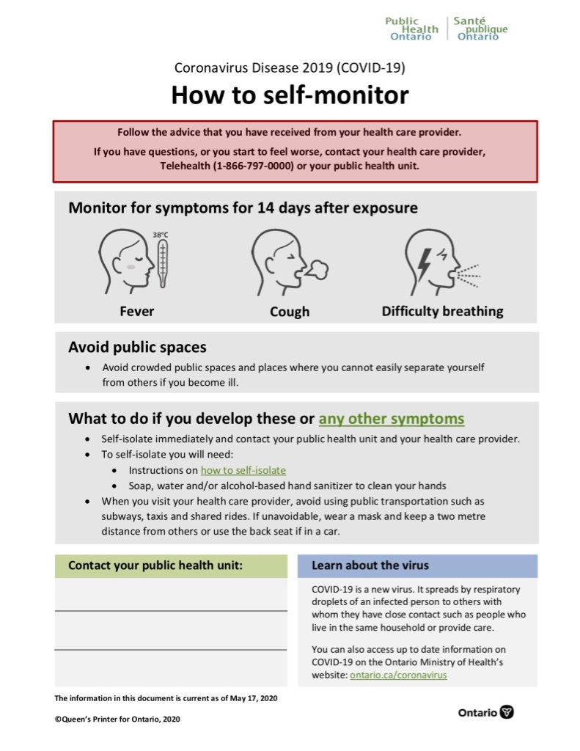

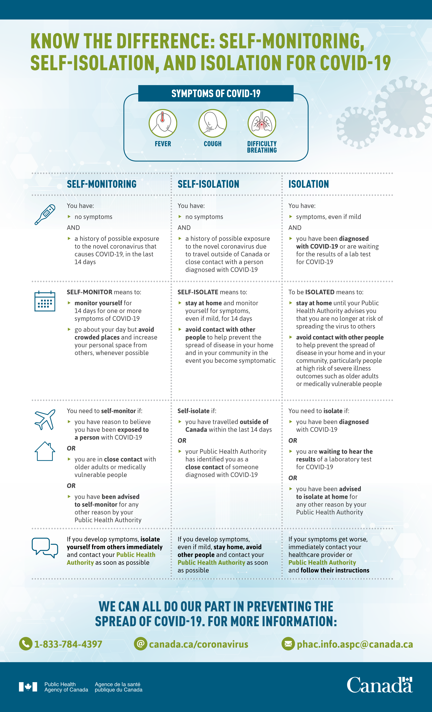
APPENDIX 1.3: SELF-MONITORING VS. SELF-ISOLATION

APPENDIX 1.4: CBP REGULATIONS
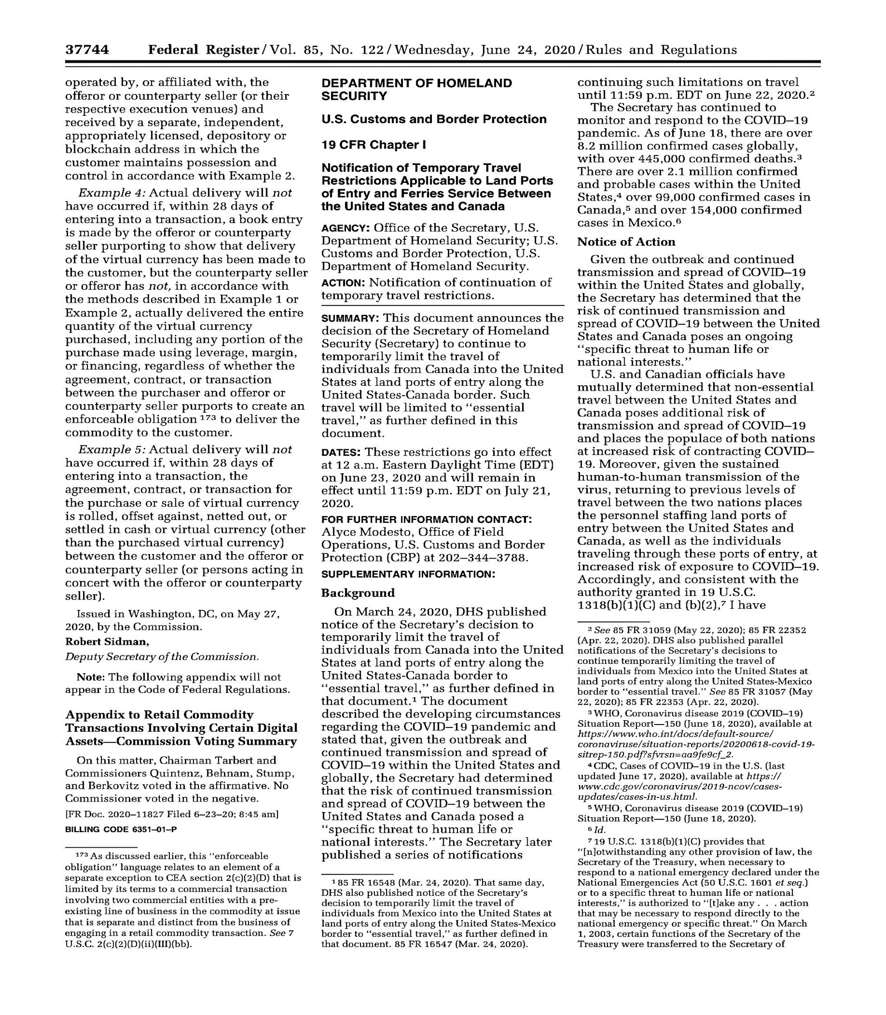

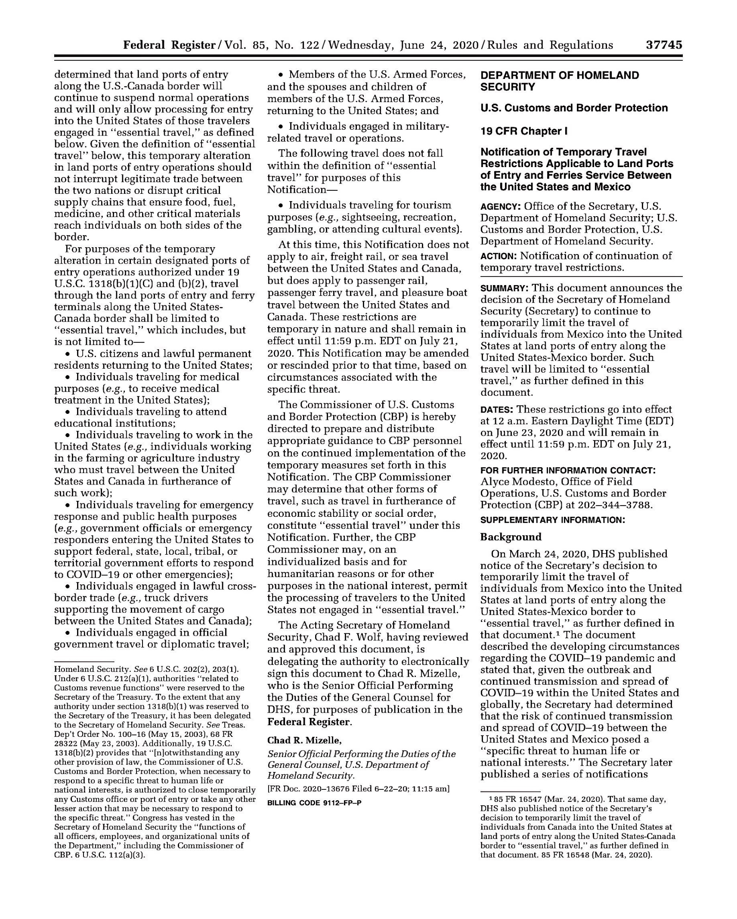

APPENDIX 1.5: QUARANTINE ACT

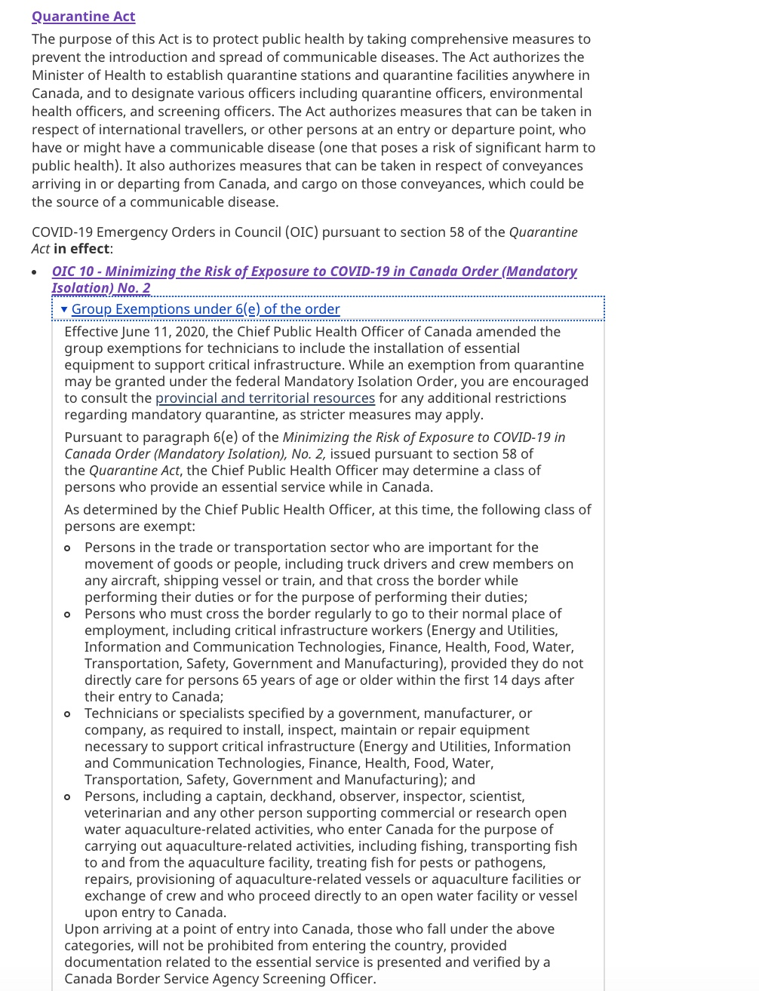

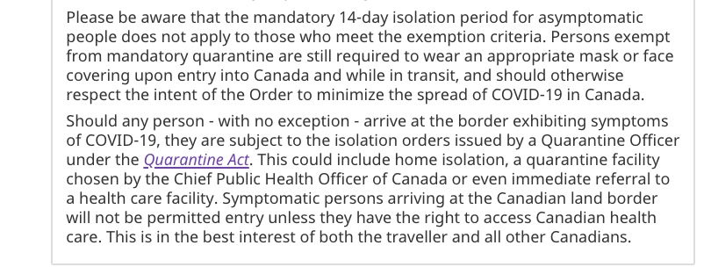

Crossing the Border: Quick Tips for Business Travelers
The following is an abridged summary of the key tips that any Cross-Border Business Traveler should have handy. It can be used as a reference for employees but does NOT contain all the information needed for safe travel.

Crossing the Border – Documentation
Documentation to Bring:
- Passport
- Essential Workers Letter
- CBP Statement on Essential Travel
- Government of Canada’s List of Acts and Regulations
Additional Information:
- Keep up to date with all COVID-19 curfews and lockdowns
- Have a copy of COVID-19 building protocols
- Emphasize that the purpose of trip is essential
- A mask MUST be worn upon entry to Canada and the United States
Crossing the Border- Tips for Safe Business Travel
Do NOT make ANY unessential stops while in the United States. Any travel that can be deemed non-essential is subject to 14-day quarantine.
- Travel in a safe reliable car with enough gas to transport to and from work
- Wear a mask and limit face to face contact
- If possible, keep all document sharing electronic
- Do NOT report to work if you or a member of your household is sick
- Carry hand sanitizer and frequently wash hands
- Bring sanitized wipes (if not provided) and wipe down all workstations
- Do NOT touch your face
- Be mindful of high touch areas and conduct regular cleaning
- Where possible, wear gloves when interacting with high contact areas. Do not touch your face with gloved hands. Take care when removing gloves. Ensure you wash your hands after removing them.
- Wash your clothes as soon as you get home
- Practice cough/sneezing etiquette (covering mouth, away from co-workers, using one’s sleeve, etc.)
Considerations for Safe Interactions with Border Services Officers:
- Avoid handling cash and paperwork, directly, use medical gloves, if possible and wash hands immediately after completing your task
- Business travellers should avoid placing their Identification in their mouth while pulling up the primary inspection lane to hand to a Border Services Officer
- When travelling, ensure wipes and sanitizers are available on-hand if possible

Public Safety Canada has developed a set of functions deemed essential in the context of the COVID-19 pandemic to help provinces/territories, Indigenous communities, and municipalities protect their communities while maintaining the reliable operation of critical infrastructure services and functions to ensure the health, safety, and economic well-being of the population. These services and functions can also help the private sector self-identify as essential. Public Safety Canada identified ten key sectors that have workers performing duties in an essential service or function, they are: Energy and Utilities; Information and Communication Technologies; Finance; Health; Food; Water; Transportation; Safety; Government; and Manufacturing.
For Canada, please refer to Canada’s National Strategy for Critical Infrastructure; for USA, please refer to the Presidential Policy Directive -- Critical Infrastructure Security and Resilience (PPD-21)

